**Jacob Stallings [Dec 20]**

**Springboard Data Science Career Track**

**Guided Capstone 1**

# Report - Big Mountain Resort

After reviewing the data and considering many potential factors that could influence ticket price charged by resorts across the country, we have developed a machine learning model that can, with a reasonable degree of accuracy, suggest a price that Big Mountain Resort is justified in charging for their tickets. This report summarizes the insights gained from the process of exploring the data, developing the model, and predicting Big Mountain’s recommended price. It also summarizes some ways in which Big Mountain can act on these findings to improve their business model.

## Key Insights

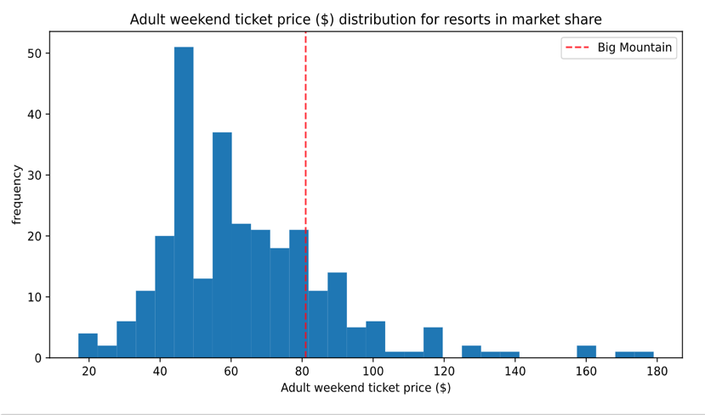The current price charged by Big Mountain Resort for an adult weekend ticket is $81. The model, which took into account key features that drive price higher in other ski resorts, such as vertical drop, number of lifts, and skiable terrain area, yielded a suggested price output of $98 per ticket. The model is expected to be off on predictions by an average of about $10, so this suggested price should not be regarded as gospel. Still, this suggests that there is definitely evidence in the data to support a price increase by Big Mountain.

## Scenarios

The business leaders provided several numbered scenarios for changing the setup of the resort to justify an increase in price. Scenario 1 was closing down some runs, but as shown in the figure below, this would support a drop in price, not an increase. Scenario 4 was extending the longest run, but the model showed that this would have little effect.

The scenarios that did show promise were Scenarios 2 & 3, which both consisted of adding a run to increase the vertical drop of the resort by 150 ft, with the added cost of installing an additional chair lift for that run.

In both of these scenarios, support was shown for increase in per ticket price by $1.27, increasing revenue by around $2.2M.

## Recommendations

Big Mountain’s original goal was to generate more revenue to offset the operational cost of their new lift, approx. $1.5M. Knowing all that we do now from the data, we can recommend with a lot of confidence that Big Mountain increase their price by at least $5. This would bring the price up to $86/ticket from its previous $81, and would generate a predicted revenue increase of $8.75M for the season. This would be well enough to cover the operating costs of the new lift and then some. Big Mountain has the facilities that are important to customers and this recommended increase in price is justified.

It is not recommended that Big Mountain implement any of the scenarios they mentioned. As explained in the section above, only one action had support for price increase as determined by the model, which was adding another run to increase vertical drop. However, the projected revenue gain from this action is only $2.2M. Subtract the cost of having to add and operate yet another new lift to bring people up from this new run, and you have revenue that may not even cover the operational costs of the lift already added. Therefore, we believe it is not worth Big Mountain’s while to implement any of those scenarios, but instead just set the price a little higher. Big Mountain has some of the best skiing in the beautiful state of Montana, and a slight increase in price is justified and should be implemented before the upcoming season.